**Assignment: Network Security, Maintenance, and Troubleshooting Procedures**

# Section 1: Multiple Choice

1. What is the primary purpose of a firewall in a network security infrastructure?

Ans: B) Filtering and controlling network traffic

1. What type of attack involves flooding a network with excessive traffic to disrupt normal operation?

Ans: A) Denial of Service (DoS)

1. Which encryption protocol is commonly used to secure wireless network communications?

Ans: B) WPA (Wi-Fi Protected Access)

1. What is the purpose of a VPN (Virtual Private Network) in a network security context?

Ans: a) Encrypting network traffic to prevent eavesdropping

# Section 2: True or False

1. Patch management is the process of regularly updating software and firmware to address security vulnerabilities and improve system performance.

Ans: **True**

1. A network administrator should perform regular backups of critical data to prevent data loss in the event of hardware failures, disasters, or security breaches.

Ans: **True**

1. True or False: Traceroute is a network diagnostic tool used to identify the route and measure the latency of data packets between a source and destination device.

Ans: **True**

# Section 3: Short Answer

8) Describe the steps involved in conducting a network vulnerability Assignment.

ANS:

Step 1: Planning and Preparation

In the planning and preparation phase of a network vulnerability assessment, you need to define the scope by determining what systems, networks, and applications will be tested. Set clear objectives, such as identifying vulnerabilities or testing security controls, and obtain written authorization from the organization to perform the assessment.

Step 2: Information Gathering

During the information gathering phase of a network vulnerability assessment, you'll map the network layout using tools to identify devices like routers, switches, firewalls, and connected devices. You'll also create an inventory of hardware and software assets and collect configuration data, including files, diagrams, and documentation, to understand the network's setup and potential vulnerabilities.

Step 3: Vulnerability Identification

In the vulnerability scanning phase, select suitable tools like Nessus, OpenVAS, or Qualys for scanning. Configure these tools to match the assessment's objectives, ensuring they're set up to scan the network effectively. Finally, conduct scans to identify vulnerabilities in devices, applications, and network services.

Step 4: Exploitation

In the exploitation phase, try to exploit identified vulnerabilities in a controlled manner to confirm their existence and assess potential impact without causing service disruptions. Additionally, test whether these vulnerabilities can lead to higher-level access within the network, known as privilege escalation.

Step 5: Risk Analysis and Prioritization

In this step, assess the impact of vulnerabilities on confidentiality, integrity, and availability. Determine how likely each vulnerability is to be exploited based on factors like ease of exploitation and existing security controls. Assign a risk rating to prioritize which vulnerabilities to fix first.

Step 6: Reporting

In the reporting phase, create a detailed report listing all vulnerabilities with their risk ratings and evidence. Provide actionable recommendations for fixing each vulnerability. Include an executive summary summarizing the security posture and critical issues.

Step 7: Remediation Planning

In remediation planning, collaborate with network administrators and stakeholders to create an action plan. Prioritize actions based on risk ratings. Assign responsibilities to team members for implementing the plan.

Step 8: Implementation of Fixes

In implementing fixes, apply patches and updates, make security configuration changes, and remove unnecessary services to address vulnerabilities.

Step 9: Verification and Validation

After fixing vulnerabilities, retest the network to confirm they're resolved. Establish continuous monitoring to detect new vulnerabilities and maintain security.

Step 10: Review and Improvement

After the assessment, hold a review meeting with stakeholders to discuss findings and improvements. Update security policies based on lessons learned. Schedule the next assessment to maintain network security.

**Section 4: Practical Application**

9) Demonstrate how to troubleshoot network connectivity issues using the ping command.

ANS:

Step-by-Step Guide

* Open Command Prompt or Terminal:

On Windows, press Win + R, type cmd, and press Enter. On macOS or Linux, open the Terminal application.

* Ping Your Own IP Address:

Find your IP address using ipconfig (Windows) or ipconfig / ip a (mac OS/Linux). - ping <your -ip -address>

This checks if your computer can communicate with the network.

* Ping the Local Host (127.0.0.1):

This tests whether your computer's network interface is working.

- ping 192.168.29.1

If the ping is successful, you will see replies from 192.168.29.1. This indicates that the local network stack is functioning properly.

* Replace “www.yahoo.com” with the desired host or IP address in the command:

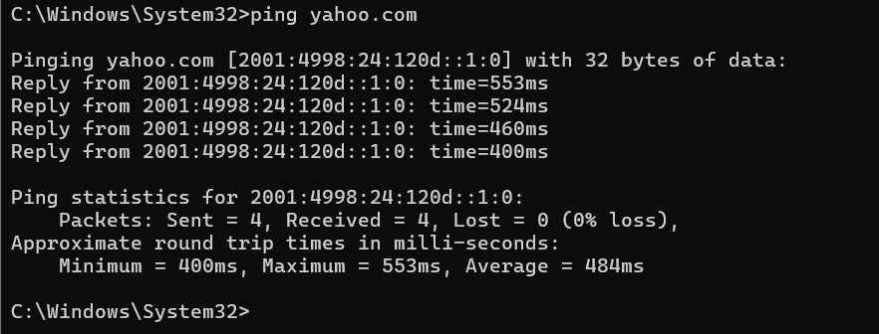

If the connection is successful, you'll see a series of responses showing the round-trip time.

To stop the pinging process, press Ctrl + C. Otherwise, it will continue sending packets.

Here,

* **min:** minimum time to get a response
* **avg:** average time to get responses
* **max:** maximum time to get a response

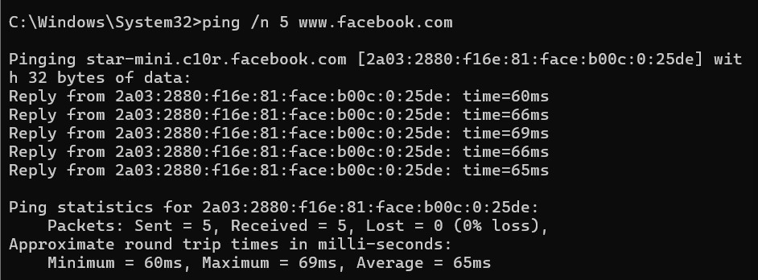

* if you want to ping www.facebook.com with 4 echo requests, each with a Data field size of 100 bytes, the command will look like this:

* + ping /n 4 /l 100 [www.facebook.com](http://www.facebook.com/)

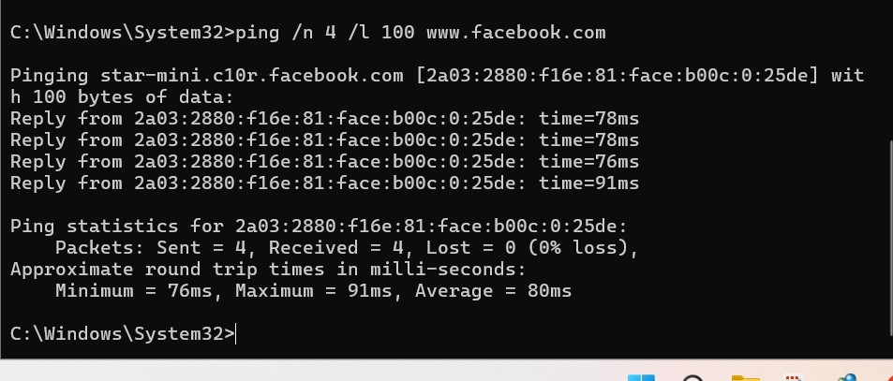

Ping Command Options Explained

* /t (Continuous Ping)

Windows: The /t option sends repeated echo requests to the specified host until you manually stop it. By default, a single ping command sends 4 echo requests unless you use /t.

Example: ping /t www.facebook.com

Linux: By default, the ping command in Linux sends echo requests continuously until you interrupt it (usually with Ctrl + C).

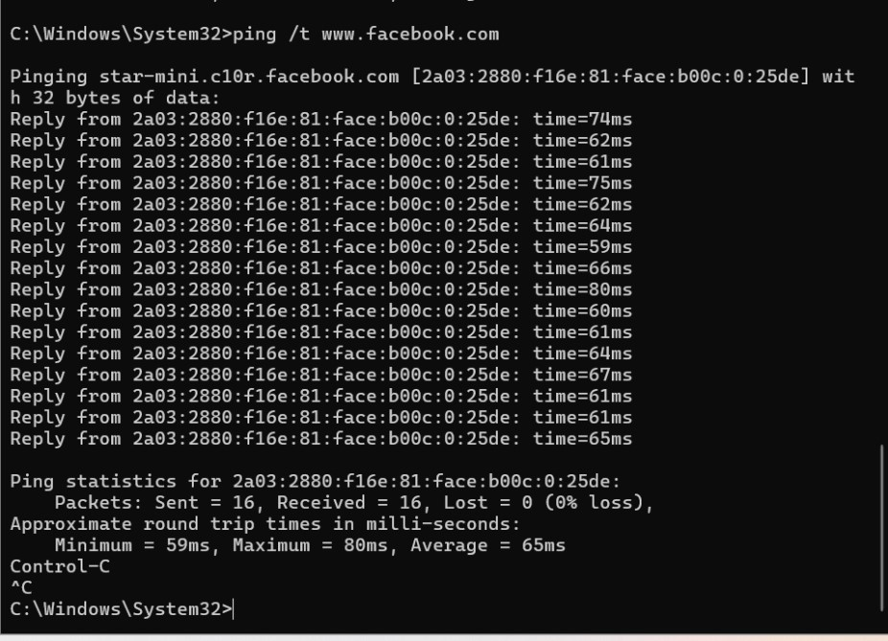

* /n (Number of Echo Requests)

The /n option is used to specify the number of ICMP echo requests to send.

Example: To send 5 ICMP echo requests to Facebook, use the command: • ping -n 5 www.facebook.com

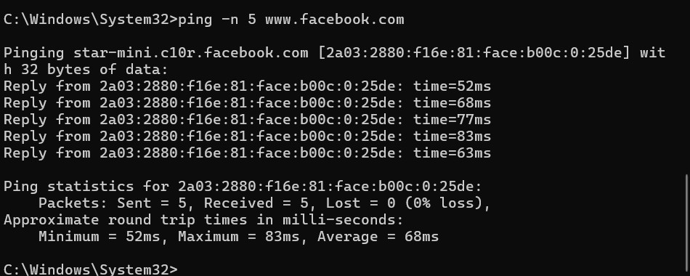

* /a (Resolve Hostname)

The /a option is used to resolve the hostname from an IP address. This can be useful if you have an IP address and want to find out the associated hostname.

Example: To resolve the hostname for the IP address 157.240.23.19, use the command:

* + ping -a 157.240.23.19

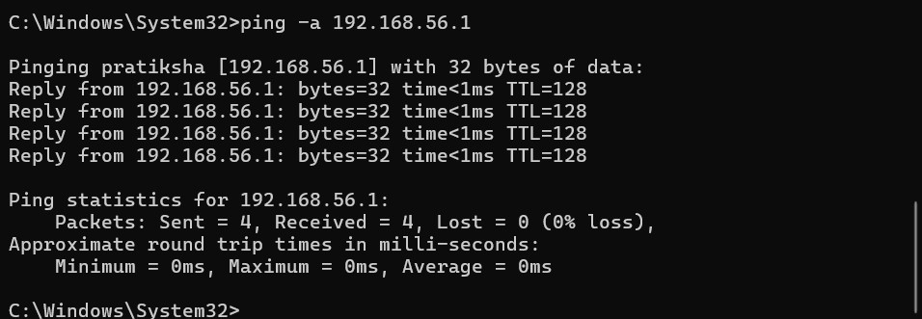

In summary:

* Use /t for continuous pings (Windows) or just ping in Linux for continuous pinging.
* Use /n followed by a number to specify the number of pings.
* Use /a to find the hostname from an IP address.

## Ping command options on Linux

* /t - this is used for sending repeated echo requests until it is uninterrupted. In Windows systems, a single ping command sends 4 echo requests unless specified. The commands look like this: ping /t www.facebook.com
* In Linux, the system sends ping requests continuously unless interrupted.
* /n - as mentioned earlier, is to set the number of ICMP packets sent with the ping command. For example, to send 5 ICMP echo requests to Facebook, the command will look like: ping -n/ 5 www.facebook.com
* /a - to resolve hostname from IP address. For example: ping -a 192.240.29.19
* -c - to specify the number of ICMP packets sent with the ping command. For example: ping -c 6 www.facebook.com
* -i - to set the interval between packets. By default, the interval is one second. For example, to set 7 seconds: ping -i 7 www.facebook.com
* -f - to send the maximum number of packets at the highest speeds allowed by the network. For example: ping -f www.facebook.com

**Section 5: Essay**

10) Discuss the importance of regular network maintenance and the key tasks involved in maintaining network infrastructure.

Ans:

Regular network maintenance is like giving your car a regular tune-up to keep it running smoothly. It involves monitoring performance, updating software, managing configurations, backing up data, conducting security audits, maintaining hardware, managing user access, and documenting changes. This proactive approach helps prevent issues and keeps your network secure and reliable.

* **Performance Monitoring:** Keeping an eye on network performance helps identify and resolve issues like slow speeds and congestion.

* **Software Updates:** Regularly updating network devices with the latest software patches and firmware ensures they are protected against vulnerabilities.

* **Configuration Management:** Managing network configurations ensures consistency and helps quickly recover from failures.

* **Backup and Disaster Recovery:** Regular backups of network configurations and critical data help in recovering from disasters or system failures.

* **Security Audits:** Regular security audits help identify and fix vulnerabilities, ensuring the network is protected from cyber threats.

* **Hardware Maintenance:** Regular maintenance of network hardware prevents failures and ensures optimal performance.

* **User Access Management:** Managing user access rights prevents unauthorized access and protects data.

* **Documentation**: Maintaining documentation of network infrastructure and maintenance activities helps in troubleshooting and planning for the future.